**ABES Engineering College-Optical Society of America (OPTICA)Student Chapter** 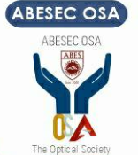

With a vision of strengthening our ties with international organizations, forums and institutions under the International Collaboration Cell, the **Department of Electronics and Communication Engineering** has successfully started the **International Student Chapter with the Optical Society of America (presently Optica)“ ABESEC OSA”.**The Optical Society's objective is to foster knowledge development, distribution, application, and archiving in Optics and Photonics. The society is involved in a variety of scientific and technical endeavors. The chapter produces and hosts an annual optics and photonics conference, bringing renowned speakers to provide seminars and researchers to discuss their work. Several professional lecturers are regularly invited to address a student chapter audience with fresh results in their particular academic pursuits, as well as trips to their workplaces.

**1. International Student Chapters “ABESEC OPTICA” (formerly ABESECOSA) and IEEE MTTS have organized National Engineers’ week from February 20, 2023 to February 24, 2023.**

Several events were conducted and lectures from renowned professionals from industry and academia were organized for the benefit of students.

* February 20, 2023: Quizzinar by “ABESEC OPTICA”
* February 21, 2023: Guest Lecture on “Role of IPR in academia and research” by Ms. Neha Goyal, Director, Patents, Unipatrde Consultants LLP
* February 22, 2023: Guest Lecture on “Entrepreneurial Ecosystem & Opportunity” by Mr. Saurav Kumar, General Manager (In Charge), Technology Business Incubator- KIET
* February 23, 2023: Poster Design competition on “Optics and photonics”
* February 24, 2023: Felicitation of winners

**Snapshots of various events are as under:**

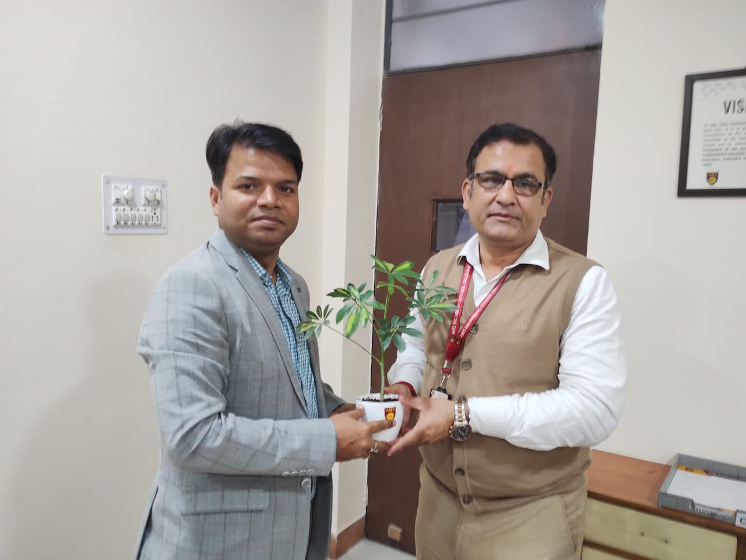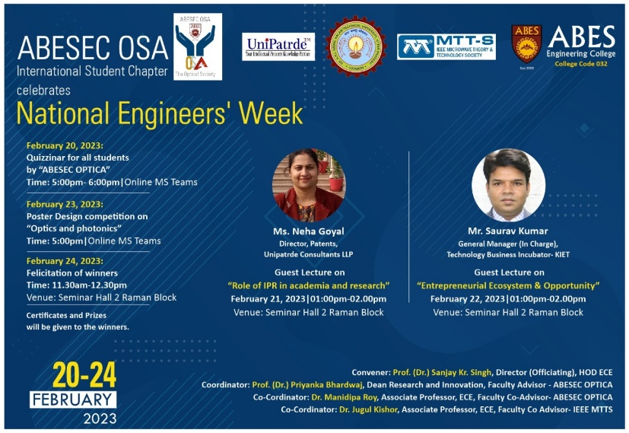

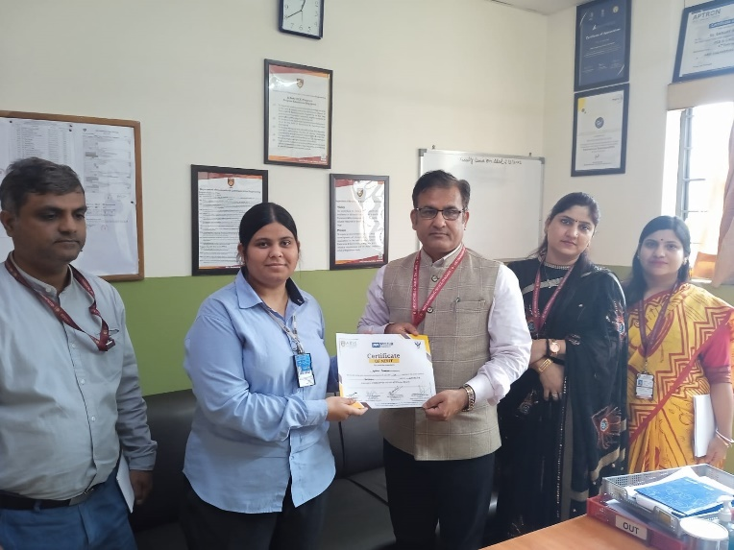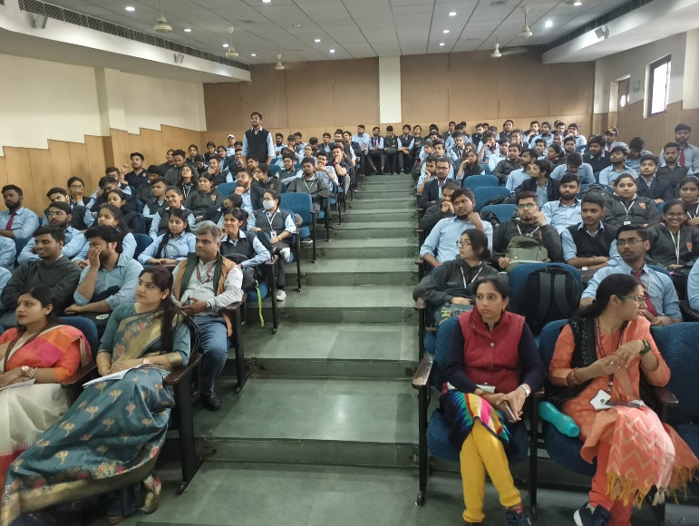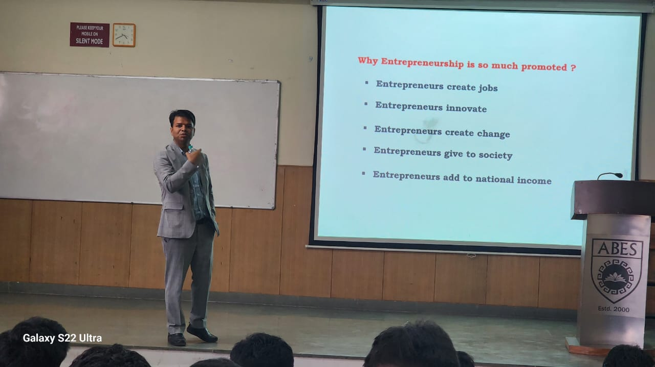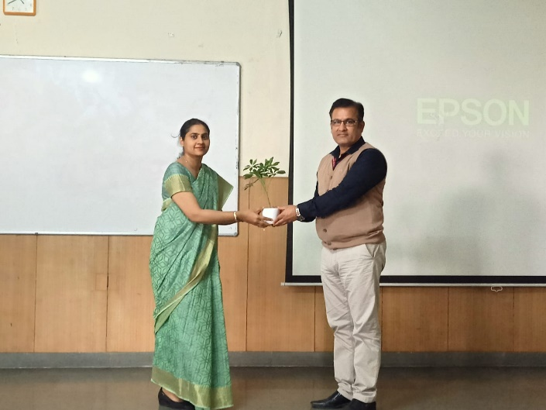

2. **International Student Chapter “ABESEC OPTICA” (formerly ABESECOSA) has orgnized National Engineers’ week from February 19, 2024 to February 23, 2024.**

**Outcome:**The National Engineers' Week created a dynamic learning environment, bridging the gap between theoretical knowledge and practical applications. By incorporating a variety of events and engaging professionals the students have been inspired to foster a sense of community within the department, which has contributed to the holistic development of future engineers in the field of Electronics and Communication Engineering.

* February 19, 2024: Quizzinar by “ABESEC OPTICA”
* February 20, 2024: Guest Lecture on “Importance of Technology Transfer” by Ms. Somya Kaushik, Associate Vice President, Elpis Analytix
* February 21, 2024: Guest Lecture on “Importance of IPR in Academia and Research” by Ms. Pooja Kumar, Director, Innove Intellects, Ghaziabad
* February 22, 2024: Poster Design competition on “Optics and photonics”
* February 23, 2024: Felicitation of winners

